**Group 4**

**Iteration 1 includes:**

**Android Studio Code**

* Implements the deliverable for iteration 1, which was a database of LCS players that can be searched utilizing certain criteria
* (No Criteria) 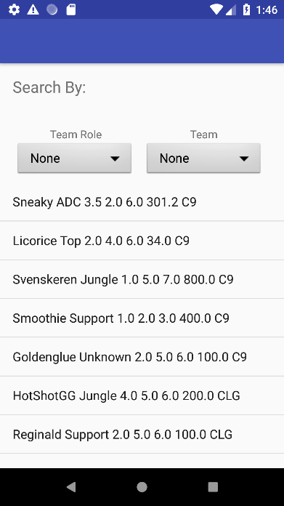
* (C9 Team criteria)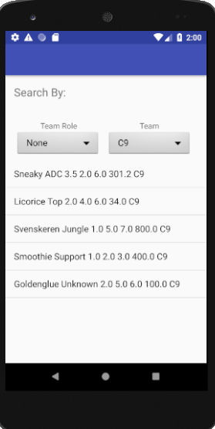

**Observer.mdj file**

* Class Diagram
* Domain Model Diagram
* Use Case Diagram
* Sequence Diagram (under Domain Model -> Collaboration1 -> Interaction1)

**Requirements.docx file**

* Requirements
* Abstract use cases

**High Level Use-Cases.docx file**

* High level use cases
* Expanded use cases
* Abstract use cases

**Scenario Description.docx**

* Scenario & tables for iteration 1 deliverables

**BrainstormClassification Domain.docx**

* Brainstorming sheet for domain modeling